Bungalow At Gondia.
1. Project Information
- Project Name: __________________
- Location: Gondia.
- Plot Area: __________________
- Built-up Area: __________________
- Project Type: Luxury private bungalow
- Status: __________________
- Completion Year: __________________

2. Project Overview
A contemporary luxury bungalow designed around spacious interiors, landscaped outdoor areas and a grand arrival experience. The architecture combines clean geometric masses with soft arches, warm finishes and large glazed openings. The overall planning creates a strong connection between the residence and its surrounding landscape.

3. Building Features
- Grand double-height entrance
- Large arched and rounded openings
- Full-height glazing for natural light
- Warm wood-finish façade highlights
- Integrated linear façade lighting
- Landscaped entrance court and lawn
- Buddha feature wall with accent lighting
- Central driveway with sculptural feature
- Covered parking area
- Pergola seating and outdoor lounge
- Flowering plants, hedges and mature trees
- Stepping-stone pathways and garden courts

4. Overall Design Concept
The design blends modern geometric architecture with softened arches and warm natural materials. Neutral exterior tones, timber finishes, subtle lighting and extensive landscaping create an elegant yet welcoming residence. The concept focuses on a seamless indoor–outdoor experience with a calm, resort-like character.

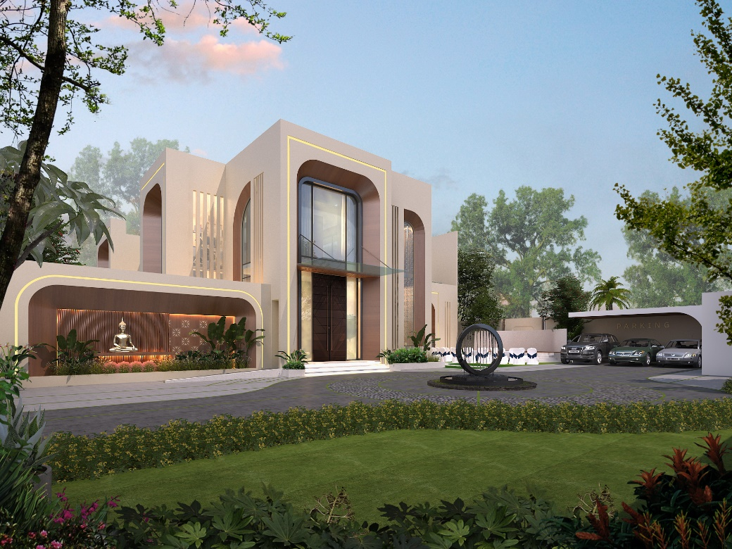
Image 1
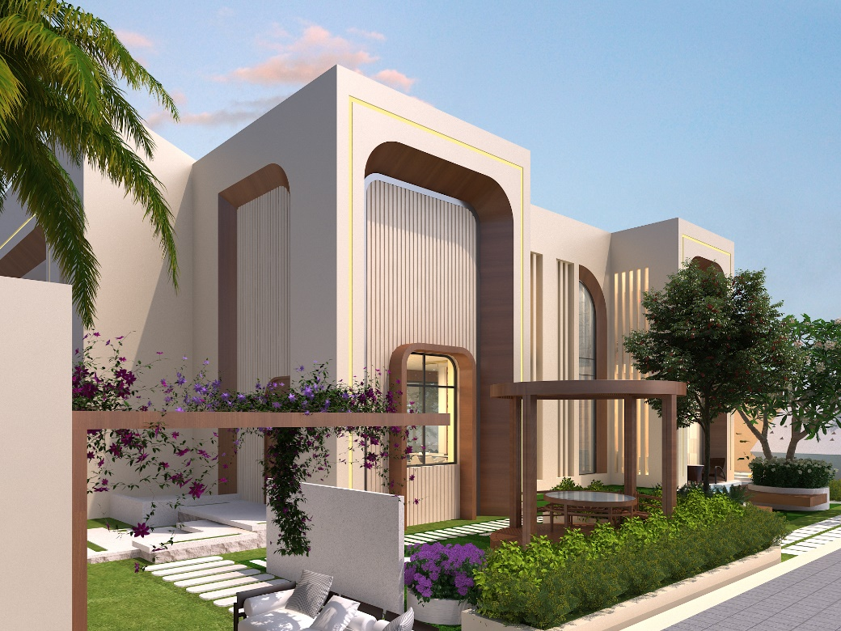
Image 2

